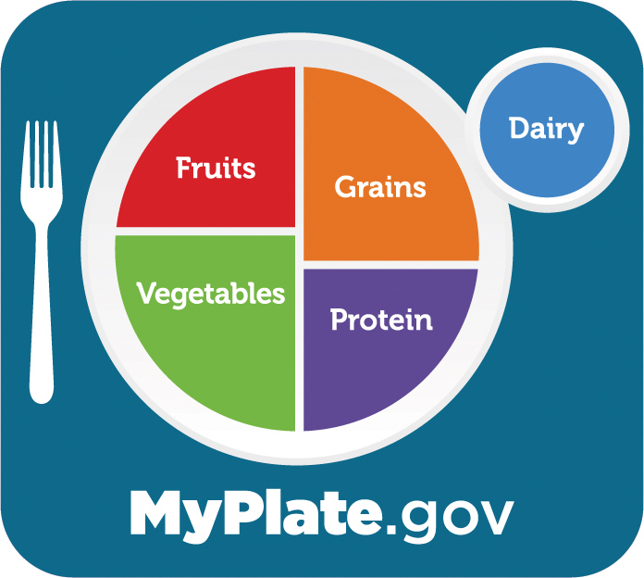
Project SMILE Nutrition Program

Over 60 and Guests over 60:
Suggested Donation: $3.00 per meal

(Meals are provided to anyone age 60 and over free of charge through a limited grant from the Older Americans Act. In order to help keep the program going, we do ask a free-will donation for these meals, which are used to assist other area senior to receive these meals. Meal Services will not be affected by your inability and/or choice not to donate/contribute. Any and all donations toward the actual cost of the meal are greatly appreciated.)

Anyone Under 60 – price per meal: $12.25
(unless married to someone 60 years old or over participating in the meal program)

